**Aim:**

To create a web form that accepts a user’s name and age and to write a servlet to process the form date and display it back on the browser.

Program:

a) Registration.html

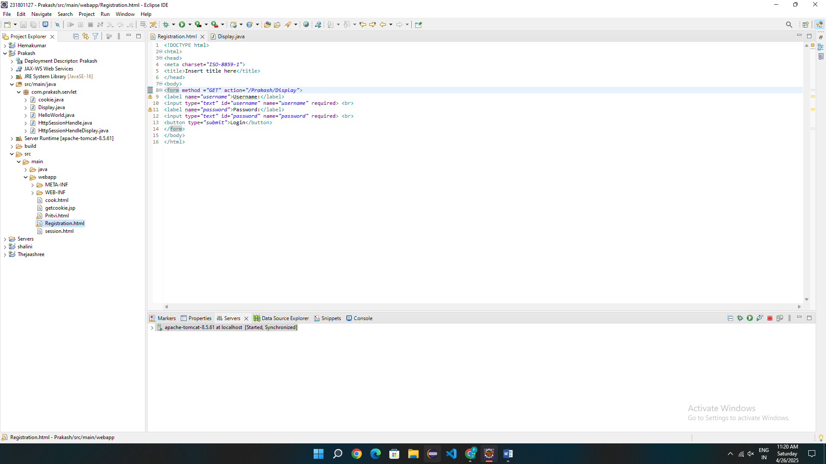

b) Display.java

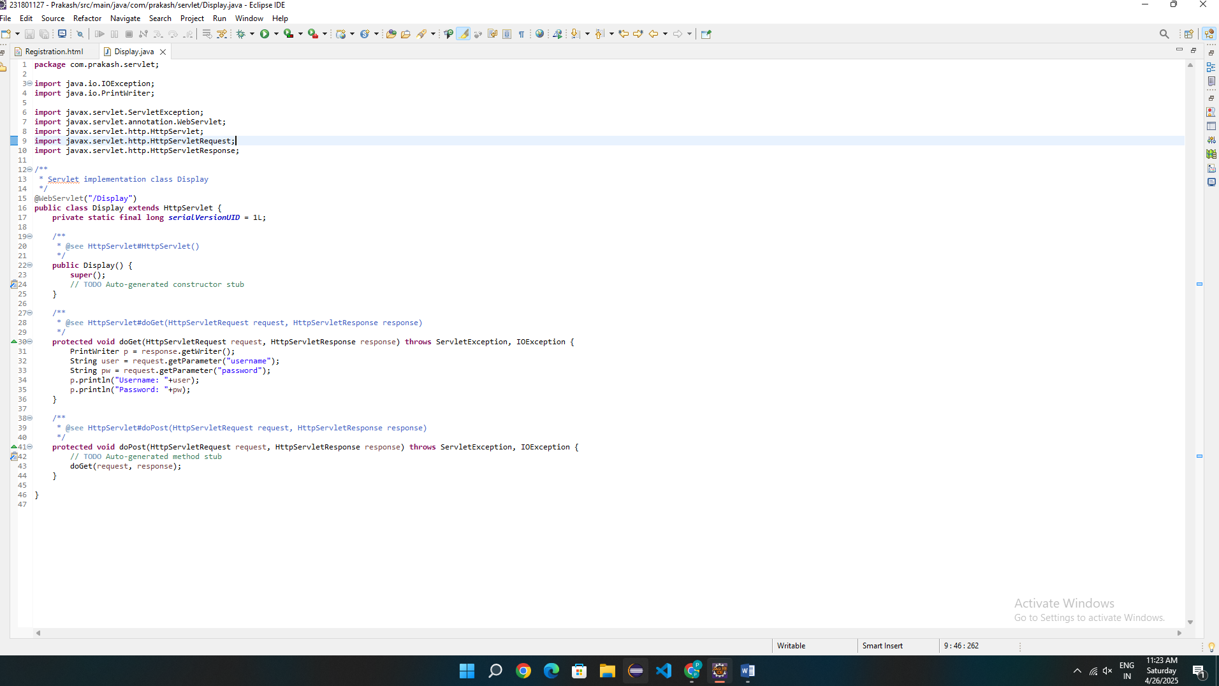

Code:

1) Registration.html

<!DOCTYPE html>

<html>

<head>

<meta charset=*"ISO-8859-1"*>

<title>Insert title here</title>

</head>

<body>

<form method =*"GET"* action=*"/Prakash/Display"*>

<label name=*"username"*>Username:</label>

<input type=*"text"* id=*"username"* name=*"username"* required> <br>

<label name=*"password"*>Password:</label>

<input type=*"text"* id=*"password"* name=*"password"* required> <br>

<button type=*"submit"*>Login</button>

</form>

</body>

</html>

2)Display.java

**package** com.prakash.servlet;

**import** java.io.IOException;

**import** java.io.PrintWriter;

**import** javax.servlet.ServletException;

**import** javax.servlet.annotation.WebServlet;

**import** javax.servlet.http.HttpServlet;

**import** javax.servlet.http.HttpServletRequest;

**import** javax.servlet.http.HttpServletResponse;

/**

* Servlet implementation class Display

*/

@WebServlet("/Display")

**public** **class** Display **extends** HttpServlet {

**private** **static** **final** **long** ***serialVersionUID*** = 1L;

/**

* **@see** HttpServlet#HttpServlet()

*/

**public** Display() {

**super**();

// **TODO** Auto-generated constructor stub

}

/**

* **@see** HttpServlet#doGet(HttpServletRequest request, HttpServletResponse response)

*/

**protected** **void** doGet(HttpServletRequest request, HttpServletResponse response) **throws** ServletException, IOException {

PrintWriter p = response.getWriter();

String user = request.getParameter("username");

String pw = request.getParameter("password");

p.println("Username: "+user);

p.println("Password: "+pw);

}

/**

* **@see** HttpServlet#doPost(HttpServletRequest request, HttpServletResponse response)

*/

**protected** **void** doPost(HttpServletRequest request, HttpServletResponse response) **throws** ServletException, IOException {

// **TODO** Auto-generated method stub

doGet(request, response);

}

}

Result: Thus the program to print the username and password in the web browser is implemented successfully.